Module 07 – Maximal Flow

Exploratory Data Analysis

*In this section, you should perform some data analysis on the data provided to you. Please format your findings in a visually pleasing way and please be sure to include these cuts:*

* *Make a visual graph of your data like what we saw for the sample problem*

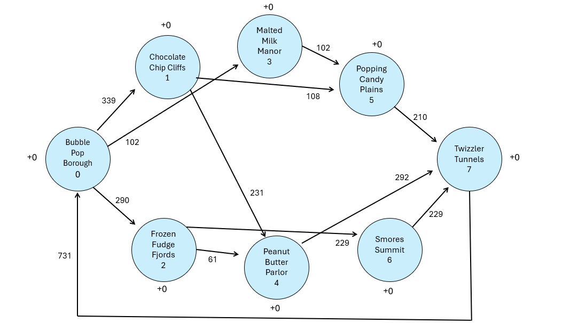

Model Formulation

*Write the formulation of the model into here prior to implementing it in your Excel model. Be explicit with the definition of the decision variables, objective function, and constraints.*

*Units of flow >= 0*

*Units of flow <= Upper Bound*

*Net Flow = Supply/Demand*

Model Optimized for Maximal Flow

*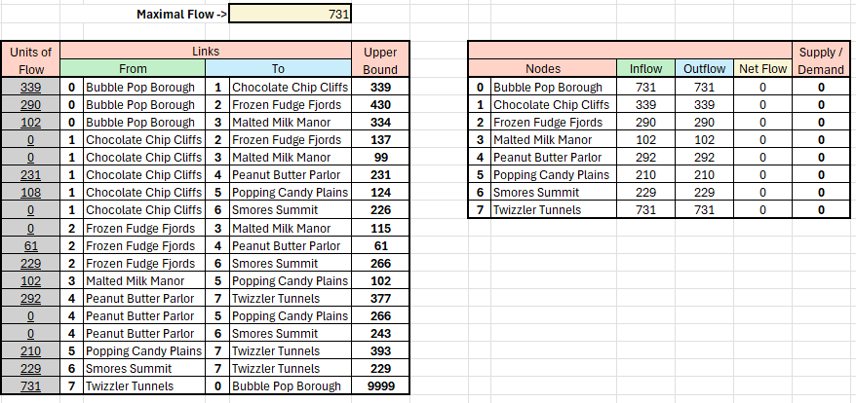*

The model is recommending circulating 731 units from all 7 locations, eventually returning all 731 units from Twizzlers Tunnels to Bubble Pop Borough.

Model with Stipulation

*Please copy the tab of your original model before continuing with the next part to avoid messing up your original solution.*

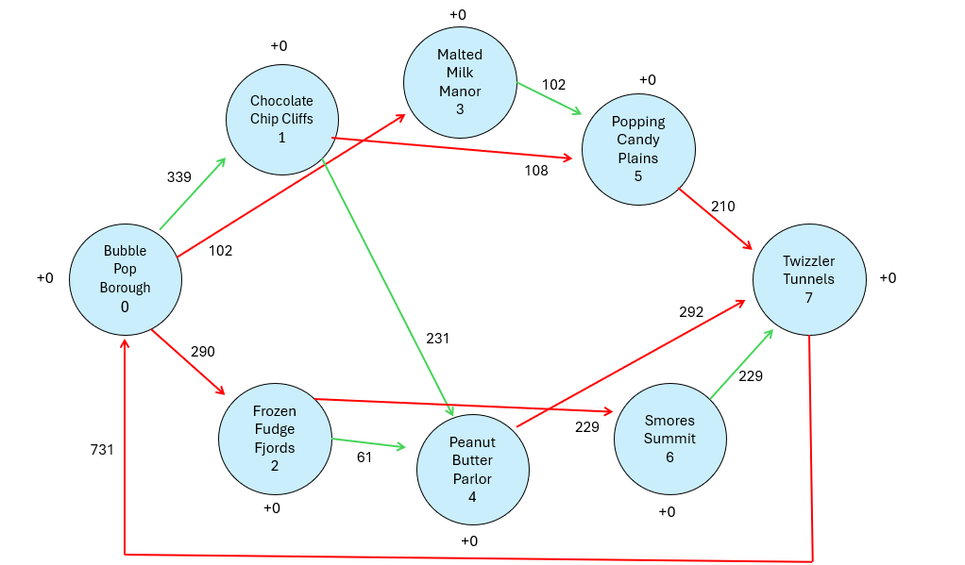

Red = node is underutilized.

Green = node is at capacity.

To increase the optimal solution – expand the bottlenecks because they are limiting how much inventory can circulate.